
Privacy Impact Assessment
Paycheck8
Revision: [2]
Forest Service
Date: April, 2008

USDA PRIVACY IMPACT ASSESSMENT FORM

Agency:
USDA Forest Service
System Name:
Paycheck8
System Type: Major Application
General Support System
Non-major Application
System Categorization (per FIPS 199): High
Moderate
Low
Description of the System:
Paycheck8 is a system to gather “time and attendance” data from the user, validate it with respect to the business rules, present it for user verification, and form it into files which are transferred to the NFC for processing in the production of payroll reports. These payroll reports are used to generate bi-weekly salary payments to USDA Forest Service employees.
Who owns this system? (Name, agency, contact information)
Name: Laree Edgecombe
Title: Assistant Director, Human Capital Management Systems
Agency: US Forest Service
Address: 1601 N Kent St, Room 600, Arlington, VA 22209
Telephone Number: (703) 605-0820
E-mail Address: ledgecombe@fs.fed.us
Who is the security contact for this system? (Name, agency, contact information)
Name: Paul Poplett
Title: Human Resources Specialist, Human Capital Management Systems
Agency: US Forest Service
Address: 3900 Masthead NE Mail Stop 208, Albuquerque, NM 87109
Telephone Number: (505) 563-9421
E-mail Address: ppoplett@fs.fed.us
Who completed this document? (Name, agency, contact information)
Name: C. Victor Havens
Title: Project Manager
Agency: GDC Integration, Inc.
Address: 710 North Tucker Boulevard, St. Louis, Missouri 63107
Telephone Number: (314) 621-1866 x3
E-mail Address: vhavens@gdcii.com

DOES THE SYSTEM CONTAIN INFORMATION ABOUT INDIVIDUALS IN AN IDENTIFIABLE FORM?
Indicate whether the following types of personal data are present in the system
QUESTION 1  Does the system contain any of the following type of data as it relates to individual: | Citizens | Employees
Name | No | Yes
Social Security Number | No | Yes
Telephone Number | No | No
Email address | No | No
Street address | No | No
Financial data | No | No
Health data | No | No
Biometric data | No | No
QUESTION 2  Can individuals be uniquely identified using personal information such as a combination of gender, race, birth date, geographic indicator, biometric data, etc.?  NOTE: 87% of the US population can be uniquely identified with a combination of gender, birth date and five digit zip code | No | Yes
Are social security numbers embedded in any field? | No | No
Is any portion of a social security numbers used? | No | Yes
Are social security numbers extracted from any other source (i.e. system, paper, etc.)? | No | Yes
If all of the answers in Questions 1 and 2 are NO,
You do not need to complete a Privacy Impact Assessment for this system and the answer to OMB A-11, Planning, Budgeting, Acquisition and Management of Capital Assets,
Part 7, Section E, Question 8c is:
3. No, because the system does not contain, process, or transmit personal identifying information.
If any answer in Questions 1 and 2 is YES, provide complete answers to all questions below.

DATA COLLECTION
- Generally describe the data to be used in the system.
Data includes the subset of EmpowHR data used in properly creating the transmission file for the NFC, and the time and attendance data entered by the users. The PII data is the SSN and employee name.
- Is the use of the data both relevant and necessary to the purpose for which the system is being designed? In other words, the data is absolutely needed and has significant and demonstrable bearing on the system’s purpose as required by statute or by Executive order of the President.
Yes
No
- Sources of the data in the system.
  - What data is being collected from the customer?
The data that is entered consists of a series of records each of which includes a start and stop time, an accounting code (“Accounting Station” or “Override”) and billing code (“Job Code”), a classification (“Trans Code” or “Transaction Code”) and, in some cases, a prefix and/or suffix which is used to further specify the classification.
The user may also add data peripheral to these records regarding their own circumstances as well as additional expenses or charges that are pertinent to their proper remuneration. These include, e.g., standard working schedule, meals received while on duty, etc.
  - What USDA agencies are providing data for use in the system?
Forest Service, NFC
  - What state and local agencies are providing data for use in the system?
None.
  - From what other third party sources is data being collected?
None.
- Will data be collected from sources outside your agency? For example, customers, USDA sources (i.e. NFC, RD, etc.) or Non-USDA sources.
Yes
No. If NO, go to question 7
  - How will the data collected from customers be verified for accuracy, relevance, timeliness, and completeness?
The user enters data into the system using a web browser to access a form. The business rules limit and specify such things as the allowable combinations of codes and classifications, and hour or time limits. Field validation is done for data type, length, and acceptable ranges.
Each set of user data must be verified and approved by another authorized Forest Service employee before it is provided to the NFC.
  - How will the data collected from USDA sources be verified for accuracy, relevance, timeliness, and completeness?
Business rules specify that data provided by EmpowHR and the NFC are definitive. The only verification is that the data must be formally correct, e.g., an SSN must be 9 digits.
EmpowHR enlists a front end edit system that is looking for valid entries in required fields. EmpowHR passes the file off to the National Finance Center, where their system validates the records more thoroughly prior to applying to the database.
The data transmitted from agencies to NFC is processed in NFC’s internal processing systems. These systems edit, reject/accept, retain/release transactions then update the database. Other internal systems (1) calculate payroll, (2) process adjustments, (3) produce output data that is disseminated to agencies and the Office of Personnel Management (OPM) and (4) prepare the database for the next pay period’s processing.
Data that does not meet the validation rules is marked as suspense, and manual entry is required to clear the data to assure it is accurate.
  - How will the data collected from non-USDA sources be verified for accuracy, relevance, timeliness, and completeness?
NA

DATA USE
- Individuals must be informed in writing of the principal purpose of the information being collected from them. What is the principal purpose of the data being collected?
Time and attendance reporting
- Will the data be used for any other purpose?
Yes
No. If NO, go to question 9
  - What are the other purposes?

- Is the use of the data both relevant and necessary to the purpose for which the system is being designed? In other words, the data is absolutely needed and has significant and demonstrable bearing on the system’s purpose as required by statute or by Executive order of the President
Yes
No
- Will the system derive new data or create previously unavailable data about an individual through aggregation from the information collected (i.e. aggregating farm loans by zip codes in which only one farm exists.)?
Yes
No. If NO, go to question 11
  - Will the new data be placed in the individual’s record (customer or employee)?
Yes
No
  - Can the system make determinations about customers or employees that would not be possible without the new data?
Yes
No
  - How will the new data be verified for relevance and accuracy?

- Individuals must be informed in writing of the routine uses of the information being collected from them. What are the intended routine uses of the data being collected?
The data is transmitted to the NFC for T&A Reporting and that data becomes part of the record that the NFC maintains on each user.
- Will the data be used for any other uses (routine or otherwise)?
Yes
No. If NO, go to question 13
  - What are the other uses?

- Automation of systems can lead to the consolidation of data – bringing data from multiple sources into one central location/system – and consolidation of administrative controls. When administrative controls are consolidated, they should be evaluated so that all necessary privacy controls remain in place to the degree necessary to continue to control access to and use of the data. Is data being consolidated?
Yes
No. If NO, go to question 14
  - What controls are in place to protect the data and prevent unauthorized access?
While Paycheck8 does consolidate data from other systems, the only data that is not publically available is the employee Social Security number (SSN) required by the NFC for T&A processing. All access to Paycheck is managed by the connectHR system with its Secure Single Signon which provides identification and authentication of the user. ConnectHR, in turn, allows the user to get eAuthentication from the USDA eAuthentication system.
Paycheck8 is working on putting an Interconnection Security Agreement (ISA) in place with the (GDCI-owned and operated) connectHR.
Paycheck users are allowed only to see their own SSN, no other user can see that data. There is no way in Paycheck8 to alter an SSN or a name.
- Are processes being consolidated?
Yes
No. If NO, go to question 15
  - What controls are in place to protect the data and prevent unauthorized access?

DATA RETENTION
- Is the data periodically purged from the system?
Yes
No. If NO, go to question 16
  - How long is the data retained whether it is on paper, electronically, in the system or in a backup?
Data is retained online, in backup or in archive indefinitely.
  - What are the procedures for purging the data at the end of the retention period?
GDCI, as a service to the USDA Forest Service, will retain Paycheck history indefinitely for historical reporting purposes. This approach provides the Forest Service with enhanced flexibility in researching issues in the future. Upon request from the Forest Service, GDCI will purge Paycheck history following agency policy and procedures.
  - Where are these procedures documented?
NA
- While the data is retained in the system, what are the requirements for determining if the data is still sufficiently accurate, relevant, timely, and complete to ensure fairness in making determinations?
NA
- Is the data retained in the system the minimum necessary for the proper performance of a documented agency function?
Yes
No

DATA SHARING
- Will other agencies share data or have access to data in this system (i.e. international, federal, state, local, other, etc.)?
Yes
No. If NO, go to question 19
  - How will the data be used by the other agency?
The only agencies with access to the data are the USDA FS HCM and the NFC. The NFC will use the data in the preparation of payroll records.
  - Who is responsible for assuring the other agency properly uses of the data?
The Payroll Department at NFC
- Is the data transmitted to another agency or an independent site?
Yes
No. If NO, go to question 20
  - Is there the appropriate agreement in place to document the interconnection and that the PII and/or Privacy Act data is appropriately protected?
There is no interconnection to any other system except the GDCI connectHR as referenced at 13.1. There are file transfers to and from the NFC by ftp over a Secure site-to-site VPN connection.
As indicated at 18.2, the Payroll department at NFC is responsible for all proper use of the data.
- Is the system operated in more than one site?
Yes
No. If NO, go to question 21
  - How will consistent use of the system and data be maintained in all sites?

DATA ACCESS
- Who will have access to the data in the system (i.e. users, managers, system administrators, developers, etc.)?
Individual data is accessible by the individual as well as others to whom the individual grants that access.
Paycheck Administrators have access to all individual’s data except for SSN’s, as do system administrators, and developers.
- How will user access to the data be determined?
Access to data is controlled through eAuthentication (or the connectHR equivalent) and assigned roles.
  - Are criteria, procedures, controls, and responsibilities regarding user access documented?
Yes
No
- How will user access to the data be restricted?
User access is role based.
  - Are procedures in place to detect or deter browsing or unauthorized user access?
Yes
No
- Does the system employ security controls to make information unusable to unauthorized individuals (i.e. encryption, strong authentication procedures, etc.)?
Yes
No

CUSTOMER PROTECTION
- Who will be responsible for protecting the privacy rights of the customers and employees affected by the interface (i.e. office, person, departmental position, etc.)?
The System Owner ultimately is responsible for the security of the system and the privacy rights of individuals.
GDCII is responsible for the security of the data. connectHR provides identification and authentication services used to limit access to authorized individuals. The security controls are documented in the System Security Plan. The C&A activity is in place to ensure the Forest Service that GDCI is meeting its obligations.
The US Forest Service Human Capital Management and the NFC are responsible for proper use of the data.
- How can customers and employees contact the office or person responsible for protecting their privacy rights?
Employees may contact the ASC-HCM regarding their privacy rights.
- A “breach” refers to a situation where data and/or information assets are unduly exposed. Is a breach notification policy in place for this system?
Yes. If YES, go to question 28
No
  - If NO, please enter the POAM number with the estimated completion date:

- Consider the following:
- Consolidation and linkage of files and systems
- Derivation of data
- Accelerated information processing and decision making
- Use of new technologies
Is there a potential to deprive a customer of due process rights (fundamental rules of fairness)?
Yes
No. If NO, go to question 29
  - Explain how this will be mitigated?

- How will the system and its use ensure equitable treatment of customers?
Each user, within the business rules, records their own time and attendance data to be used in the preparation of their payroll statement.
- Is there any possibility of treating customers or employees differently based upon their individual or group characteristics?
Yes
No. If NO, go to question 31
  - Explain

SYSTEM OF RECORD
- Can the data be retrieved by a personal identifier? In other words, does the system actually retrieve data by the name of an individual or by some other unique number, symbol, or identifying attribute of the individual?
Yes
No. If NO, go to question 32
  - How will the data be retrieved? In other words, what is the identifying attribute (i.e. employee number, social security number, etc.)?
Paycheck8 employee record ID number
  - Under which Systems of Record notice (SOR) does the system operate? Provide number, name and publication date. (SORs can be viewed at www.access.GPO.gov)
Privacy Act SOR USDA/OP-1 Personnel and Payroll System for USDA Employees
  - If the system is being modified, will the SOR require amendment or revision?
NA

TECHNOLOGY
- Is the system using technologies in ways not previously employed by the agency (e.g. Caller-ID)?
Yes
No. If NO, the questionnaire is complete.
  - How does the use of this technology affect customer privacy?

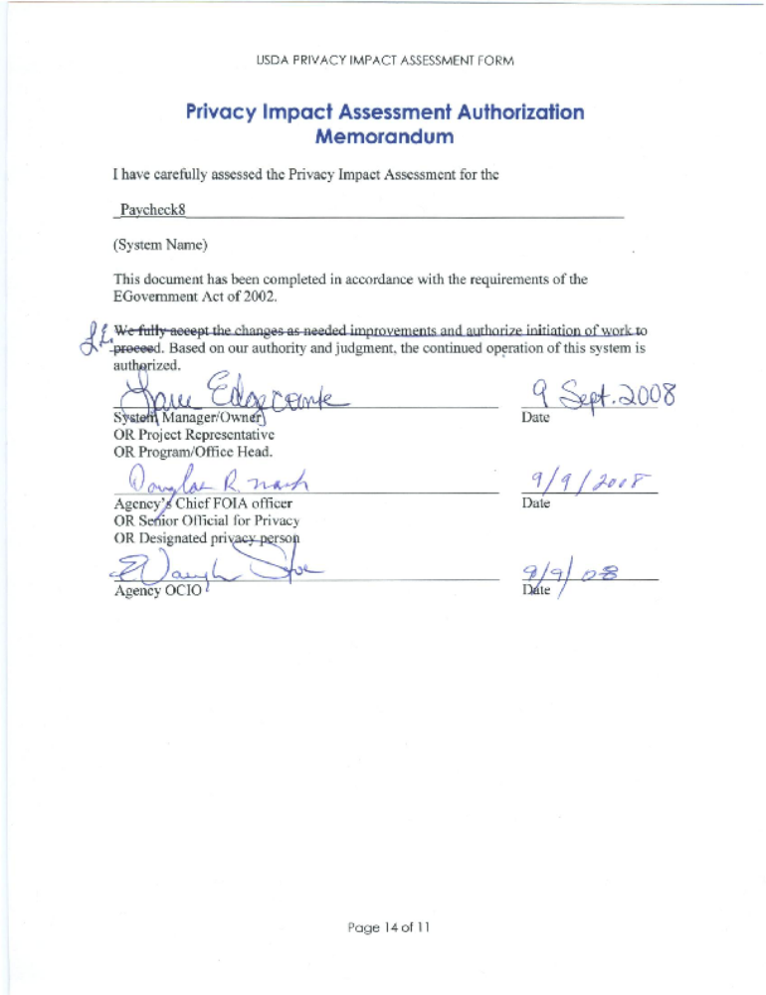PLEASE SUBMIT A COPY TO
THE OFFICE OF THE ASSOCIATE CHIEF INFORMATION OFFICE/CYBER SECURITY

Comments of Latanya Sweeney, Ph.D., Director, Laboratory for International Data Privacy Assistant Professor of Computer Science and of Public Policy Carnegie Mellon University To the Department of Health and Human Services On "Standards of Privacy of Individually Identifiable Health Information". 26 April 2002.

